**Table:**

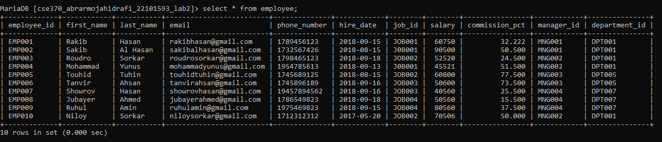

**Question 01:**

select first_name, last_name, email, phone_number, hire_date,

-> department_id from employee where hire_date=(select max(hire_date) from

-> employee);

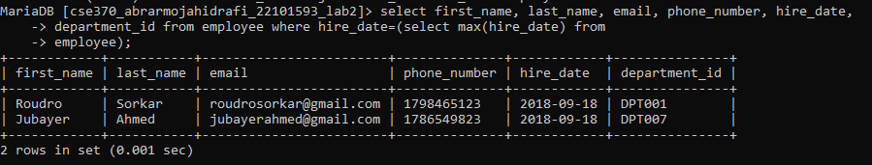

**Question 02:**

SELECT first_name, last_name, email, phone_number, MIN(salary),

-> department_id FROM employee GROUP BY department_id;

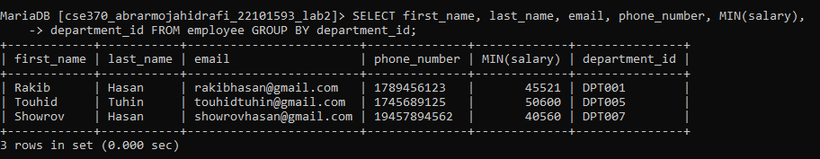

**Question 03:**

select first_name, last_name, employee_id, commission_pct, department_id

-> from employee where department_id = 'DPT007' and commission_pct < all(select

-> commission_pct from employee where department_id = 'DPT005');

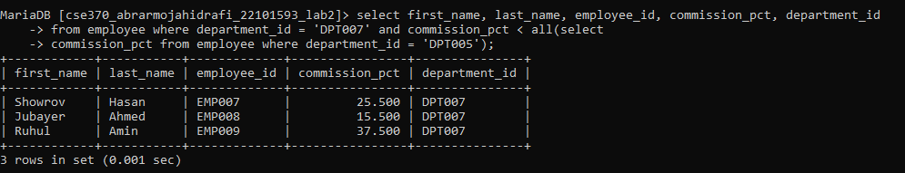

**Question 04:**

select distinct department_id, count(*) as total_Employees from

-> employee where salary < 30000 group by department_id;



**Question 05:**

select department_id, job_id, commission_pct from employee L1 where

-> exists(select * from employee L2 where L1.department_id=L2.department_id and

-> L1.job_id != L2.job_id and L1.commission_pct < L2.commission_pct);

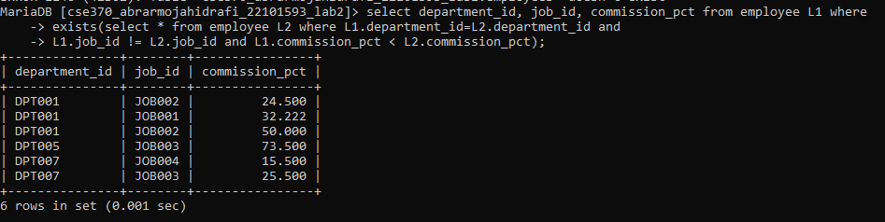

**Question 06:**

select distinct manager_id from employee where salary > 3500;

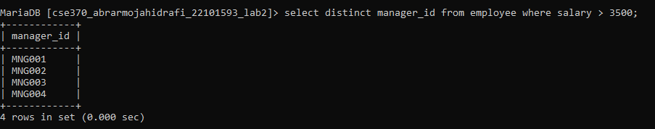

**Question 07:**

select first_name, last_name, employee_id, email, salary, department_id, commission_pct

-> from employee where (manager_id, commission_pct) in

-> (select manager_id, min(commission_pct) from employee group by manager_id);

